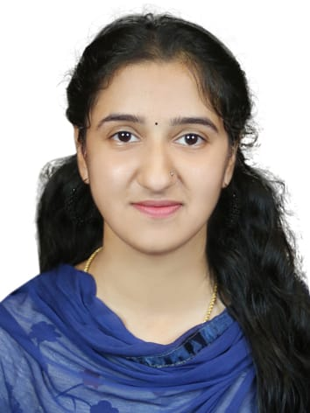

Aswathi P

[www.linkedin.com/in/aswathi-p-4824952b6](http://www.linkedin.com/in/aswathi-p-4824952b6)

+91 9778137429

aswathip9567@gmail.com

# SUMMARY

Master of Commerce (M.Com.) from Sree. Kerala Varma College, with a focus in marketing, earned in 2024. shown proficiency in marketing combined with a high aptitude for analysis and problem-solving.

**HIGHLIGHTS OF QUALIFICATION**

* Post graduation in Masters of Commerce
* Specialization in Marketing
* Bachelors in Commerce
* Knowledge in Ms. PowerPoint and Word
* Higher Secondary Education in Computer Commerce
* Excellent communication in English, Tamil, Malayalam

# EXPERIENCE

**Academic Manager | Q live – Online Tuition Center**

Kerala, India - 2024 **| https://qlivelearn.com/**

* Facilitating effective management of Leaners and Teachers
  + Processing payments effectively from enrolled Leaners
  + Generated over 50 leads in just 2 months
  + Resolving conflicts between Learners and Teacher’s effectively

**On-screen Anchor**

# Kerala, India

# Trade Stories | Trading Institute

# Codeme-mei | Coding Institute

# Kalyan 99 | Fashion store

**Student Councilor | Winzap – Learning Application**

Malappuram, Kerala, India – 2021 - 2023 **| https://linktr.ee/winzap**

* Data Collection
* Convincing parents for Lead
* Part of the team which result in 10% increase in the monthly turnover

**EDUCATION**

**Master’s in Commerce**  2022 - 2024

Sree. Kerala Varma college, Calicut university, Trissur, Kerala

**Bachelor’s in Commerce**  2019 - 2022

Ambedkar College of Arts and Science, Calicut University, Kerala

**COMMUNITY INVOLVEMENT**

* Echo - Club
* Kerala Students Union (KSU)

**REFERENCE –** Available Upon Request